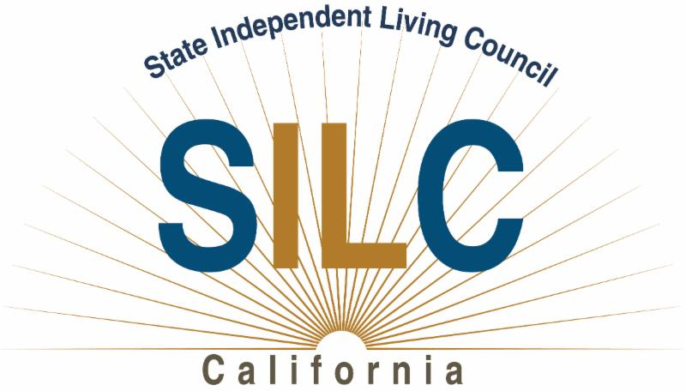

Hello participants in California’s Independent Living network,

We are actively seeking members to fill upcoming vacancies on the California State Independent Living Council (SILC).

SILC members play an active role in establishing Independent Living Policy in California through participation in development and implementation of the three-year State Plan for Independent Living.

The SILC is looking for qualified individuals to serve on the Council who:
1. provide statewide representation;
2. represent a broad range of individuals with disabilities from diverse backgrounds;
3. are knowledgeable about centers for independent living and independent living services; and are not employed by any state agency or by a Center for Independent Living.

New members should add diversity to the Council – The following groups are currently under- or un-represented on the SILC:

- Youth (defined as ages 14 to 24)
- Deaf or hard of hearing community
- Blind or low vision community
- Asian American Community
- Veterans or Veteran Community members
- Traumatic Brain Injury Community
- Native American Community
- Residents of Rural areas of California
- Person on the Autism Spectrum
- Person with Mental Illness

Expectations of SILC Members:
- Minimum time commitment of two hours every month (email reading and telephone committee meeting)
- Three-day meeting periods three to four times a year (one day for travel, two for meeting).
- Time to read materials and prepare for the meetings.
- SILC Members need to be able to travel. Recently our meetings have been in Sacramento, Los Angeles, Burlingame, and San Diego. We try to rotate locations across the state.

The SILC can cover all expenses including paying for a personal assistant to serve the governor appointee or to enable them to participate. In addition, SILC members who are unemployed or who have to forgo wages to participate in SILC activities are eligible for a $100/day stipend.

We strive for 100% disability in our leadership. At present all but one Council member identify as a person with a disability.

Desired SILC Member Characteristics:
- Leadership skills
- Knowledge of Independent Living philosophy and what it stands for
- Integrity: Members who do what they say they are going to do
It is preferred that members have served on a board or advisory committee before, and understand that it is a different kind of service from other volunteer work.

If you are interested to pursue becoming a member, please send us your current resume for review. Resumes should be sent to the SILC Executive Director, Carrie England at Carrie@calsilc.ca.gov.

Information about the SILC can be found on our website - https://www.calsilc.ca.gov/about-silc.

You can also start the application for appointment on the Governor’s website - https://www.gov.ca.gov/application-for-appointment/. There are several questions, but they are fairly easy to answer.

Please feel free to contact us at (916) 263-7905 or at Carrie@calsilc.ca.gov if you would like to learn more about becoming a SILC member.

The California State Independent Living Council is an independent state agency which, in cooperation with the Independent Living Centers, prepares and monitors the State Plan for Independent Living.
The SILC Mission: To Create Policy and System Change for Independent Living
California State Independent Living Council, 1300 Ethan Way, Suite 110, Sacramento, CA 95825

